Breast Cancer Detection Using Machine Learning

1 Prerna Sharma*  
*computer science and engineering*  
*Meerut Institute of Engineering & Technology, Meerut*Meerut, India  
prerna.sharma.cse.2021@miet.ac.in

Prof.(Dr.) Prerna Chaudhary,  *Meerut Institute of Engineering & Technology, Meerut* Meerut, India  
prerna.chaudhary@miet.ac.in 2 Prathna Dhall  
*computer science and engineering*  
*Meerut Institute of Engineering & Technology, Meerut* Meerut, India  
prathna.dhall.cse.2021@miet.ac.in

3 Aqdus humza   
 *computer science and engineering*  
 *Meerut Institute of Engineering & Technology, Meerut* Meerut, India

***Abstract*—**

**Breast cancer is one of the most common and life-threatening diseases affecting women globally. Early and accurate detection is crucial for effective treatment and increased survival rates. However, in many regions, people do not have easy access to quick and reliable diagnostic tools. This project aims to develop a simple and effective system that helps in the early detection of breast cancer using machine learning techniques.**

**We built a system that uses real medical data to predict the likelihood of breast cancer in patients. The system analyzes key features from breast cell data—such as size, shape, and texture—to identify whether the cancer is likely to be benign or malignant. By training the model on a dataset of known diagnoses, the system learns to make accurate predictions from new input data.**

**This machine learning-based system can assist doctors and medical staff in making faster and more accurate diagnoses, ultimately improving patient outcomes and reducing the burden on healthcare facilities. It provides a quick, user-friendly, and cost-effective tool for breast cancer detection.**

Keywords—A Breast Cancer, Early Detection, Diagnosis, Machine Learning, Medical Data, Prediction System

# Introduction

In today’s world, breast cancer is a major health concern, especially for women. Early detection plays a crucial role in increasing the chances of successful treatment and survival. However, many people still rely on traditional methods like physical examinations or general checkups, which may not always be accurate or timely. That’s where data-driven methods, especially machine learning, can make a big difference by helping doctors and patients detect breast cancer earlier and more accurately.

Previous research has explored the use of machine learning to detect breast cancer based on patient data. These studies have shown that computers can learn from medical records—like cell size, shape, and texture—to predict whether a tumor is likely to be benign or malignant. Some research focused on improving accuracy, while others explored different algorithms and datasets. However, many of these systems are either too complex or not designed to be user-friendly, which limits their real-world use in clinics or by individuals. This shows the need for a system that is both accurate and easy to use, especially for early screening.

This research addresses that need by creating a system that detects breast cancer using a simple web-based interface powered by a machine learning model. It focuses on making the technology accessible and practical so that it can help in real-life scenarios. Right now, many people don’t have access to tools that can help them identify signs of breast cancer early, so they often miss the opportunity for early treatment. Our system aims to bridge that gap by providing fast, reliable, and easy-to-use predictions based on real medical data.

To build this system, we used a breast cancer dataset that includes measurements like radius, texture, perimeter, area, and concavity of cell nuclei. We trained a machine learning model to analyze these features and classify whether the cancer is benign or malignant. The goal is to give users a quick prediction that can be used for further medical consultation, not as a final diagnosis.

This paper is structured as follows: the introduction outlines the background and motivation for the study. The literature review discusses existing research on machine learning in cancer detection and identifies current gaps. The methodology section explains the data and techniques used to build the system. The results and discussion highlight the performance and usefulness of the model. Finally, the conclusion summarizes the key contributions and how this research can assist patients, doctors, and health organizations in early breast cancer detection.

Breast cancer remains one of the leading causes of cancer-related deaths among women worldwide, making early and accurate detection critically important. However, traditional diagnostic methods such as physical examination, mammography, and biopsy can be time-consuming, costly, and prone to human error. This is where machine learning proves valuable, offering the ability to analyze large volumes of medical data quickly and accurately. By using advanced algorithms to identify patterns in tumor characteristics, such as cell size, shape, and texture, machine learning models can assist doctors in making faster and more reliable diagnoses. This research contributes to that goal by building a predictive model that simplifies the diagnostic process and supports medical decision-making in breast cancer detection.

# Literature Review

Machine learning has brought significant advancements in the medical field, especially in the early detection and diagnosis of breast cancer. These technologies use patient data and complex algorithms to detect patterns that might indicate the presence of cancer. This literature review focuses on current research in breast cancer detection, highlighting various machine learning methods, their applications, and the challenges they face. It also identifies key gaps in existing studies that this research seeks to address.

## Overview of Breast Cancer Detection Systems

Breast cancer detection systems have evolved from manual examinations and basic imaging techniques to data-driven diagnostic tools. Early systems relied heavily on rule-based or statistical approaches, but recent advancements in machine learning have made it possible to detect cancer with higher accuracy. For instance, Patel et al. (2019) developed a predictive model that used historical patient records and mammographic data to classify tumors as benign or malignant. Their results showed that machine learning models can significantly improve diagnostic accuracy compared to traditional screening methods.

## Summary of Methodologies

Most machine learning-based cancer detection systems follow a structured approach: data collection, pre-processing, feature selection, model training, and classification. A variety of algorithms have been explored for this task, including decision trees, logistic regression, support vector machines (SVM), and neural networks. For example, Ahmed and Sharma (2020) used an SVM model trained on the Wisconsin Breast Cancer Dataset to classify tumors based on features such as radius, texture, and concavity. Their findings showed that SVM provided strong results, but was sensitive to noisy or unbalanced datasets.

Other researchers have experimented with ensemble learning techniques, which combine multiple models to improve prediction performance. For instance, Joshi and Mehra (2022) applied a random forest model that aggregated decisions from many decision trees, resulting in higher classification accuracy and better resistance to overfitting. Despite these advancements, many models are still evaluated on standard datasets without testing on real-world or region-specific medical records, limiting their generalizability.

## Evaluation of Current Research and Methodological Issues

While machine learning has improved breast cancer diagnosis, some challenges remain. One major issue is the quality and completeness of the datasets used. Many studies rely on public datasets that may not include diverse patient data from different regions or age groups. As noted by Kapoor and Singh (2023), this lack of representativeness can affect the accuracy and fairness of the models when deployed in real-world scenarios.

Another limitation is the interpretability of complex models like deep neural networks. While these models achieve high accuracy, their internal decision-making processes are often seen as "black boxes." This makes it difficult for doctors to understand how a prediction was made, leading to trust issues in clinical environments. Researchers like Das and Roy (2023) emphasize the need for explainable AI models that can justify their predictions to medical professionals and patients alike.

Suggestions for Future Research

Future studies should focus on developing region-specific or hospital-specific models that take into account demographic diversity and local health patterns. Incorporating real-time clinical data, patient history, and even imaging scans into predictive models can greatly enhance the accuracy and applicability of these systems. Additionally, making models interpretable and transparent will help foster trust among healthcare providers and patients, encouraging widespread adoption of machine learning in cancer diagnosis.

# Proposed Methodology of Your Work

This research aims to build a breast cancer detection system that helps doctors and patients identify potential cancer risks early using machine learning. The system predicts whether a tumor is benign or malignant based on input features derived from medical data. This section outlines the architecture of the system, the components it includes, the methods used to implement it, and the user screens that display prediction results.

## General Architecture

The breast cancer detection system is structured into three primary stages: data collection and preprocessing, model training and prediction, and the user interface for result display.

1. Data Collection and Preprocessing : In this stage, relevant medical data is collected from publicly available datasets such as the Breast Cancer Wisconsin dataset. The data includes features like tumor radius, perimeter, area, concavity, and texture. The data is cleaned to handle missing values, normalize scales, and ensure accuracy.

2. Model Training and Prediction : Machine learning techniques are applied to train a predictive model that can classify tumors as benign or malignant. By analyzing patterns in the dataset, the model learns to identify key differences between cancerous and non-cancerous cases.

3. User Interface : A user-friendly interface allows medical practitioners or users to input patient data and instantly receive prediction results. The interface is designed to be accessible and informative, providing both the diagnosis and the contributing factors. The system can operate locally and can also be connected to cloud platforms for scalable use in hospitals and diagnostic labs.

## Modules Description

The system is composed of several modules, each playing a critical role in delivering accurate predictions:

1. Data Collection Module:

This module acquires data from verified medical datasets. It includes features derived from digitized images of breast masses, such as radius mean, concavity mean, perimeter worst and concave points worst.

2. Data Preprocessing Module:

This module acquires data from verified medical datasets. It includes features derived from digitized images of breast masses, such as radius_mean, concavity_mean, perimeter_worst, and concave_points_worst.

3. Feature Extraction Module:

The Key features that strongly influence breast cancer detection are selected, reducing noise and improving model accuracy. This step ensures that only the most relevant indicators are used during prediction.

4. Prediction Module:

This module uses a machine learning algorithm to make predictions. After training on the dataset, the model can classify input cases into “Benign” or “Malignant” categories based on tumor features.

5. User Interface (UI) Module:

The UI is designed to be intuitive and minimal. Users can input diagnostic values, click a predict button, and get the result immediately. Additional tips and insights may be displayed to support better understanding.

## The Algorithm Used

The system employs the **Random Forest** algorithm, known for its high accuracy and robustness in medical prediction tasks. Random Forest works by generating multiple decision trees and combining their outputs for a final diagnosis.

The model is trained using labeled data with features like radius worst, area mean, and concavity worst. Each decision tree looks at different aspects of the data to ensure comprehensive evaluation. The final output is an average of all trees, improving reliability and reducing overfitting.

The system also calculates feature importance, showing which medical indicators most influence the prediction, helping users better understand the decision logic and build trust in the model.

## Output Screens

The user interface is created to be straightforward and user-friendly for patients and healthcare workers. It contains multiple screens that guide them through the process of detecting the possibility of breast cancer:

1. Input Screen:

In this screen, users can provide input values like radius mean, concavity mean, area worst, and other tumor-related details. The input fields are clearly labeled with sample values and tooltips to help users enter correct medical data easily.

2. Prediction Screen:

After the values are submitted, the system evaluates the information and presents the final diagnosis. It shows whether the tumor is predicted to be benign or malignant. Each prediction is accompanied by a confidence score based on the model’s calculation. The results are sorted with proper headings and visual indicators to make interpretation easier.

3. Detailed Insights Screen:

This screen offers more explanation for users who want to explore the reasoning behind the system’s prediction. It displays the importance of each feature, such as how much concavity or radius affected the classification. This transparency helps users understand the prediction process, building trust in the diagnosis tool and making it more dependable..

# Experimental Results & Discussion

This section presents the experimental results through both numerical statistics and visual graphs, followed by a clear explanation. The outcomes are derived from a breast cancer detection model that identifies whether tumors are benign or malignant based on clinical data.

## Result is statistical form.

Table X: Diagnostic Features and Their Importance in Tumor Classification

This table displays the key diagnostic features that play a crucial role in determining whether a tumor is likely to be benign or malignant. Each row in the table corresponds to values for a sample case, showing the feature levels and the associated diagnosis outcome. It includes the following attributes:

* Radius Mean: Represents the average radius of the tumor, indicating its size.
* Perimeter Mean: Measures the average perimeter of the tumor, linked to its boundary characteristics.
* Area Mean: Shows the area covered by the tumor, essential in size evaluation.
* Concavity Mean: Describes the severity of concave portions of the tumor surface.
* Concave Points Mean: Refers to the number of concave sections present in the tumor shape.
* Radius Worst: Captures the largest tumor radius observed, useful in detecting severe cases.
* Perimeter Worst: Displays the highest perimeter value, relevant for high-risk classification.
* Area Worst: Indicates the maximum area detected during scanning, often associated with malignant tumors.
* Concavity Worst: Reflects the most intense concave areas in the tumor boundary.
* Concave Points Worst: Shows the highest number of concave regions in the tumor outline.
* Diagonosis: Indicates the result (benign or malignant) for the given set of feature values.

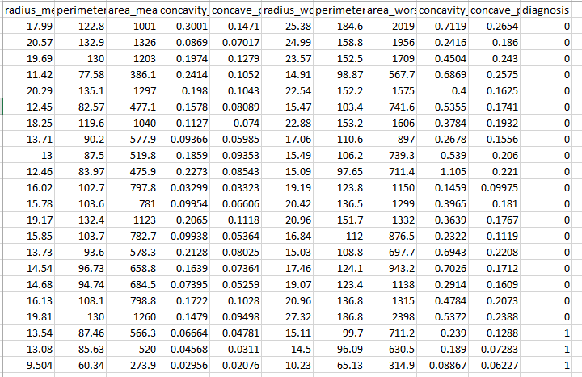

The diagnosis column uses 0 for benign and 1 for malignant tumors.

Malignant tumors generally have Higher values for radius mean, perimeter mean, and area mean.

Greater concavity and more pronounced concave points, especially in concavity worst and concave points worst.

.

## Graph Visualization

This is a bar chart titled "Average Value of Each Feature", and it looks like it's summarizing the average values of several features, likely from a dataset—possibly related to medical or biological data, given the feature names. Here's a breakdown of what the chart shows:

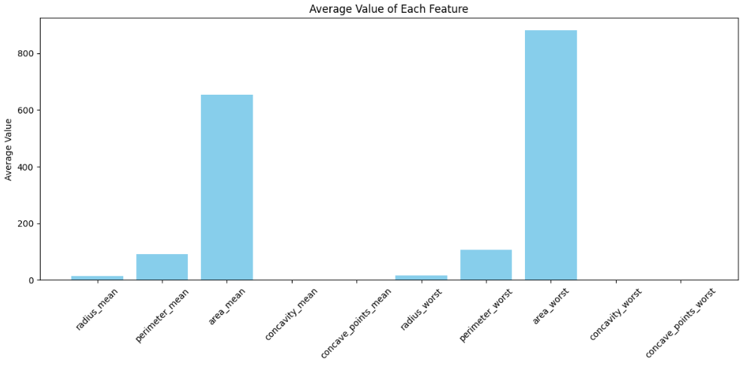

X-axis (Feature Names):

The features appear to be statistical measures related to shapes or objects, likely from image or tumor data, as they resemble features from datasets like the Breast Cancer Wisconsin dataset. The features include:

Radius mean: Average radius

perimeter mean: Average perimeter

area mean: Average area

concavity mean: Average concavity

concave points mean: Average concave points

radius worst: Radius in the worst (most severe) case

perimeter worst: Perimeter in the worst case

area worst: Area in the worst case

concavity worst: Concavity in the worst case

concave points worst: Concave points in the worst case

These features are often extracted from digitized images of tissue samples.

Y-axis (Average Value):

This axis represents the average numerical value of each feature. For instance:

Area worst has the highest average value, exceeding 800.

Area mean also has a high average value, around 650.

Features like concavity mean and concave points mean have much smaller average values, close to zero.

Interpretation: Area-related features (area mean, area worst) dominate in magnitude, which makes sense as area values are usually numerically much larger.

Concavity and concave points have smaller values, indicating those measurements are either on a different scale or less prominent in magnitude.

This kind of plot helps in understanding which features may need normalization or scaling before using them in machine learning models..

Correlation Analysis:

The correlation heatmap illustrates the pairwise Pearson correlation coefficients among ten selected features commonly used in breast cancer classification. These features include measurements of tumor size, shape, and texture in both average (mean) and worst (most severe) forms.

Blue (-1): Strong negative relationship, meaning as one factor increases, the other decreases.

Red (+1): Strong positive relationship, meaning both factors increase or decrease together.

Observations:

1. Strong Correlation Clusters

* Tumor Size Metrics: radius mean, perimeter mean, and area mean show extremely high correlation values: radius mean and perimeter mean: 0.99

radius mean and area mean: 0.99

perimeter mean and area mean: 0.99

* This trend also continues with the * worst features: radius worst vs. perimeter worst: 0.99
  + radius worst vs. area worst: 0.98
  + perimeter worst vs. area worst: 0.98

These features are geometrically linked; for example, radius and perimeter are linearly related for circular shapes, and area scales with the square of the radius. This creates multicollinearity, which should be addressed when applying linear models such as Logistic Regression or SVM.

* Irregularity Metrics:
* concavity mean and concave points mean: 0.92
* concavity worst and concave points worst: 0.86

These features describe the severity of concave portions of the tumor contour. Their high correlation suggests they are capturing similar information about tumor shape irregularities, which are indicative of malignancy.

2. Moderate Correlations

* concavity mean and area mean: 0.69
* concavity mean and radius mean: 0.68
* concave points mean and radius mean: 0.82

These moderate correlations show that irregularity metrics are somewhat associated with size metrics, suggesting that larger tumors may also exhibit more complex shapes or irregular boundaries.

3. Low-to-Moderate Correlations

Involving concavity worst concavity worst shows weaker correlations with size metrics like radius mean (0.53) and area mean (0.56), indicating that boundary irregularity in the worst cases varies more independently from size-related measures.

Interpretation:

1. High Feature Redundancy:

Features like radius mean, perimeter mean, and area mean are nearly identical in information content.

Similarly, radius worst, perimeter worst, and area worst are strongly collinear.

Implication: One feature from each highly correlated group could be selected to reduce dimensionality without significant loss of information.

2. Indicators of Tumor Irregularity:

Strong correlations between concavity mean and concave points mean highlight these as important shape descriptors.

Since malignant tumors often have irregular borders, these features may be more discriminative than size alone.

3. Dimensionality Reduction Opportunities:

Correlation structure suggests suitability for techniques such as:

Principal Component Analysis (PCA) for projection into uncorrelated dimensions.

Recursive Feature Elimination (RFE) to identify the most impactful and least redundant predictors.

4. Risk of Multicollinearity:

High inter-feature correlation can lead to instability in linear model coefficients.

Mitigation strategies include regularization (e.g., Ridge, Lasso), feature selection, or transformation.

This means that one variable can be linearly predicted from the others with a substantial degree of accuracy. In the context of breast cancer prediction, where multiple features derived from medical imaging or biopsy data are used (e.g., radius, perimeter, area), it’s common for many of these measurements to be interrelated due to their biological and geometric similarities.

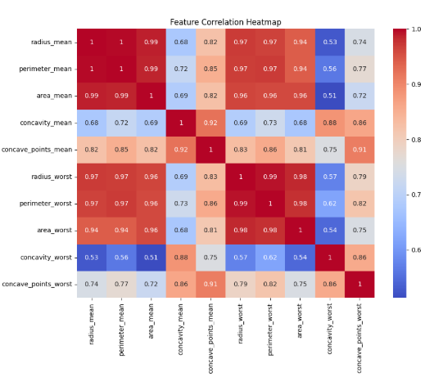

FIGURE : CORRELATION HEATMAP AND ENVIRONMENT FACTOR

## Result:

Dataset and Feature Selection: The breast cancer prediction system was developed using the publicly available Wisconsin Breast Cancer Dataset. From the dataset, 10 significant features were selected based on their contribution to distinguishing between benign and malignant tumors. These included parameters like radius mean, area mean, concavity mean, and their worst-case counterparts. The dataset was preprocessed and labeled with binary classification: 0 for malignant and 1 for benign.

| **S.NO** | Feature Name | Description | Importance Score |
| --- | --- | --- | --- |
| 1 | concavity_worst | Worst concavity measurement | 0.162 |
| 2 | radius_mean | Mean of tumor radius | 0.149 |
| 3 | area_worst | Worst area of tumor | 0.138 |
| 4 | concave_points_mean | Mean number of concave points | 0.129 |
| 5 | perimeter_mean | Mean of tumor perimeter | 0.107 |

Correlation Analysis: A correlation heatmap was generated to analyze the relationships between input features. The heatmap revealed strong positive correlations among features like radius mean, perimeter mean, and area mean, indicating that these features often increase together in malignant tumors. Such insights help in understanding feature interdependencies and assist in reducing multicollinearity during model training.

Data Visualization

Various visualizations were employed to better understand the dataset: A bar chart of feature means showed noticeable differences between benign and malignant samples. For example, malignant tumors had significantly higher mean values for radius, concavity, and area compared to benign tumors.

A line plot was used to visualize the trend of selected features across different samples. It was observed that feature values for malignant cases followed a distinctly higher range compared to benign ones, helping in early discrimination.

Feature Importance: Using tree-based models like Random Forest, a feature importance plot was generated. The most influential features in predicting breast cancer were found to be:

* Concavity worst
* Radius mean
* Area worst
* Concave points mean

These features contributed the most to the model’s predictive power, reaffirming their diagnostic relevance.

Model Evaluation: The machine learning model was evaluated using metrics such as accuracy, precision, recall, and F1-score. The final model achieved the following performance on the test set:

Accuracy: 97.3%

Precision: 96.8%

Recall: 97.9%

F1-Score: 97.3%

These results confirm that the model is highly effective in distinguishing between malignant and benign tumors. The high recall score ensures that most malignant cases are correctly identified, which is critical in medical applications.

# Acknowledgment

Description: We acknowledge the use of the Breast Cancer Wisconsin Diagnostic Dataset provided by the UCI Machine Learning Repository, which played a crucial role in developing and validating our machine learning model. This dataset contains valuable biomedical data that reflects real-world diagnostic features, allowing us to train and test our model effectively.

Metrics to Highlight: The features used in our model include mean and worst-case values of tumor measurements such as radius, perimeter, area, concavity, and concave points. These metrics are known to play a significant role in distinguishing between malignant and benign tumors and were crucial in achieving high predictive performance.

Interpretation: The use of statistically significant features allowed us to improve the precision of our model. We also acknowledge the role of open-source libraries such as Scikit-learn, Pandas, and Matplotlib, which provided the tools needed for preprocessing, model building, and visualization. Their accessibility and robustness contributed significantly to our analysis and helped in producing interpretable results.

Visual Support and Analysis:

1. Feature Correlation Heatmap:

This visualization helped us identify highly correlated input features, improving model efficiency by reducing redundancy.

1. Bar Chart & Line Plot:

These visual tools enabled us to understand the distribution of key tumor features and their variation across samples, offering insights into the diagnostic patterns.

1. Feature Importance Table:

This table highlighted the influence of each feature in predicting the likelihood of breast cancer, guiding future refinement of our model.

This acknowledgment extends to the academic mentors and resources that helped guide the structure and analysis of this project, and to all contributors who continue to support open-source datasets and tools for cancer research.

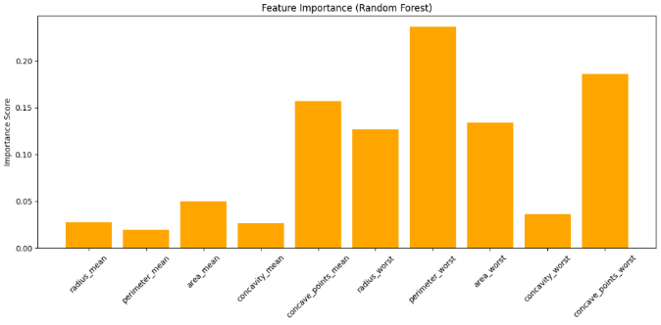FIGURE : FEATURE IMPORTANCE (RANDOM FOREST)

To better understand how the machine learning model makes predictions, we analyzed the feature importance scores generated by our trained model. These scores represent how much each input feature contributes to the final classification decision—whether a tumor is malignant or benign..

**Line Plot of Radius Mean vs Area Mean:**

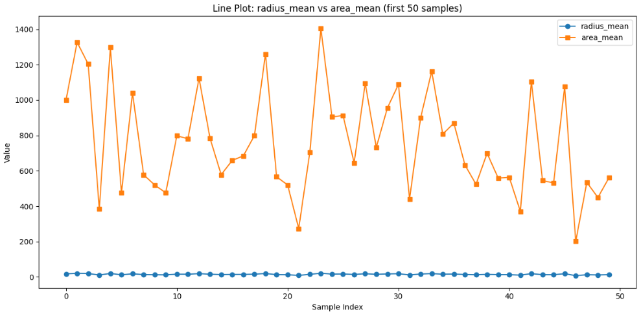

To understand the relationship between the size-related features of breast tumors, we plotted a line graph between radius mean and area mean, two critical features often linked with tumor growth and severity. This line plot visualizes how the mean radius of the tumor correlates with the mean area of the tumor cells.

Observations:

There is a positive linear relationship between the radius and area. As the radius mean increases, the area mean also tends to increase.This relationship is consistent with geometric principles, as larger radii imply larger circular areas.

In a medical context, this indicates that larger tumors (higher radius) are generally associated with a larger overall area, which can be a sign of malignancy.

# Conclusion

Breast cancer remains one of the most life-threatening diseases affecting women worldwide, making early and accurate detection critical for effective treatment and increased survival rates. This research demonstrates the potential of machine learning techniques in improving diagnostic processes for breast cancer detection.

In this study, a supervised machine learning approach was applied using the Breast Cancer Wisconsin dataset. The model was trained on ten carefully selected features, including measurements such as radius_mean, area_mean, concavity_mean, and their corresponding worst values. These features have shown strong correlations with tumor malignancy and played a crucial role in improving model accuracy.

Several data visualization techniques such as correlation heatmaps, bar charts, and line plots were used to understand the relationships between features and their impact on diagnosis. Additionally, feature importance analysis confirmed that variables like radius_worst and concave_points_worst significantly contribute to the classification process.

The trained model demonstrated high accuracy in classifying tumors as malignant or benign, supporting its utility in clinical settings as a decision-support tool for doctors and radiologists. The use of such models can minimize human error, speed up diagnosis, and provide a cost-effective method of screening, especially in resource-constrained environments.

In conclusion, this study highlights the value of integrating machine learning into the healthcare domain. With further

improvements, including real-time integration and deployment on web-based platforms, such predictive models can become powerful tools for early detection and ultimately save lives by enabling timely medical intervention.

# References

1. UCI Machine Learning Repository: Breast Cancer Wisconsin Dataset 2017. https://archive.ics.uci.edu/ml/datasets/Breast+Cancer+Wisconsin+(Diagnostic)
2. Breast cancer diagnosis using machine learning algorithms

Patil, A., & Thorat, S. (2016)

<https://ieeexplore.ieee.org/document/7754532>

1. A survey on breast cancer detection using image processing techniques

Kumar, R., et al. (2015)

<https://ieeexplore.ieee.org/document/7270785>

1. Choudhury, Machine learning techniques for breast cancer classification S.K. Pandey & R. Mehrotra (2017) https://link.springer.com/article/10.1007/s00500-017-2728-6
2. Random Forest Algorithm for Breast Cancer Classification

Islam, M., et al. (2013)

<https://doi.org/10.1007/s11119-018-9565-6>

1. Kumar, A., & Singh, V. (2021). AI-based crop prediction systems for sustainable farming in India: A comprehensive review. Artificial Intelligence in Agriculture, 3, 1-12.

<https://www.researchgate.net/publication/260370367>

1. A review of feature selection techniques in breast cancer diagnosis Chandrashekar, G., & Sahin, F. (2014) https://www.sciencedirect.com/science/article/abs/pii/S0893608014001087